Justin Reid

Effectiveness of fall training program on back squat performance.

We decided to look at the back squat data over two different time periods to see how the training was working.

Shown below are two plots of the back squat weight. The y axis is the back squat weight in pounds; the horizontal axis is an ID for the athletes. ~~The supplied dataset had many missing values making analysis difficult. For simplicity only athletes who had values for the entire course of the time frame were included in this analysis.~~

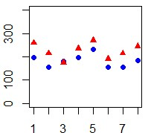

Plot of the back squat weights for September 2013 (Blue) and September 2014 (Red). Vertical axis is weight squatted in lbs. and horizontal axis is the index corresponding to when the weight was recorded.

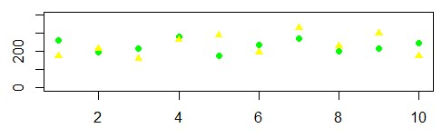

Plot of back squat weights for September 2014 (Green) and December 2015 (Yellow). Vertical Axis is weight squatted in lbs. and horizontal axis is the index corresponding to when the weight was recorded.

The two plots indicate that over the course of the training squat performance has improved for the athletes as evidenced by the increase in weight seen from Sep2013 – Sep2014 and Sep2014-Dec2015. However athletes made the most improvements in September 2013 – September 2014 compared to gains made in the September 2014 – December 2015 time period. In the first time period nearly all of the athletes with the exception of one made increases in weight squatted. The mean of increase in squat weight for September 2013 – September 2014 is 44.7 lbs. compared to a mean increase of 4.5 lbs. for September 2014 – December 2015. This might be due to the athletes making such dramatic gains in the first year that only incremental increases could be made in the following year.